NASA PLANETARY DEFENSE
Near-Earth Asteroid Risk & Prioritization Analysis
"Only a small fraction of Near-Earth Asteroids pose a true catastrophic threat —
but finding them in time is everything."

Team Members | Pihu Jaitly · Aanya Mehrotra · Aditya Rana · Harshil · Krishna
Project Title | Asteroid Risk Analysis & Planetary Defense Dashboard
Sector | Space / Aerospace / Planetary Defense
Team ID | SectionC_G-09
Institute | Newton School of Technology
Data Source | NASA JPL Center for Near Earth Object Studies (CNEOS)
Scope | Asteroid data up to 2025; Close approaches through 2035
Submission Date | April 2026

1. Executive Summary
Problem
Space agencies and planetary defense organizations track over 41,000 Near-Earth Asteroids (NEAs), yet telescope time, analyst resources, and tracking budgets are finite. The core challenge is signal-to-noise: only ~2–3% of all tracked NEAs are classified as Potentially Hazardous Asteroids (PHAs), yet these objects represent the entirety of civilization-scale risk. Without a structured analytical framework, critical threats can be lost in a sea of benign objects.
Approach
Data was sourced directly from NASA JPL's CNEOS via API and CSV export, resulting in two datasets: 41,281 asteroid records and 27,430 close-approach events spanning 2015–2035. An ETL pipeline built in Python (Pandas/NumPy) merged, cleaned, and enriched the data — including imputing missing diameters from Absolute Magnitude (H). Logistic regression and correlation analysis were applied, and findings were surfaced in two interactive Tableau dashboards.
Key Insights
- Only 6–7% of tracked NEAs are Potentially Hazardous, but these account for all catastrophic impact risk.
- 2029 is a peak-risk year due to Apophis passing within ~31,000 km of Earth's surface.
- Over 15% of newly discovered NEAs have observation arcs under 30 days, creating dangerous trajectory blind spots.
- Asteroids with unknown albedo may be underestimated in size by up to 100%, masking true kinetic energy threat levels.
Key Recommendations
- Automate telescope queuing for PHAs with data arc deficits to resolve trajectory uncertainty within 30 days of discovery.
- Prioritize space-based IR observations for city-killer-class objects (>140m) lacking albedo data.
- Implement a mandatory multi-agency early warning protocol for any PHA projected to cross the 5 Lunar Distance threshold.

2. Sector & Business Context
Planetary defense sits at the intersection of astronomy, geopolitics, and risk management. Unlike most emerging threats, an asteroid impact is one of the few natural disasters that is both predictable and potentially preventable — given sufficient lead time. NASA's Planetary Defense Coordination Office (PDCO), ESA's Space Safety Programme, and JAXA collectively monitor the NEA population, but resource constraints mean that not every discovered object receives equal scrutiny.
Industry Challenges
- Detection Surge: Modern survey telescopes (ATLAS, Catalina Sky Survey, PanSTARRS) discover hundreds of new NEAs monthly. The Vera Rubin / LSST observatory, when fully operational, will increase discovery rates by an order of magnitude.
- Prioritization Gap: There is no unified, data-driven scoring system that automatically ranks newly discovered objects by threat urgency — decisions still rely heavily on analyst judgment.
- Albedo Uncertainty: Without space-based infrared observations, asteroid sizes are inferred from optical brightness (H magnitude) and assumed albedo values. Darker asteroids appear smaller than they are, creating a systematic underestimation risk for potentially hazardous objects.
- Budget Constraints: Planetary defense receives a fraction of NASA's total budget. The DART mission success (2022) demonstrated deflection is feasible, but monitoring infrastructure remains underfunded relative to the scale of the detection challenge.
Decision-Maker This Project Serves
The primary stakeholder is the NASA PDCO administrator and equivalent leads at ESA/JAXA. Secondary audiences include telescope scheduling teams, congressional science committees, and international coordination bodies. This project delivers an operational dashboard that enables these decision-makers to prioritize monitoring resources without requiring deep technical expertise in orbital mechanics.
Business Value of Solving This Problem
A missed PHA event on the scale of the 1908 Tunguska impact (roughly 10–15 megatons) over a populated area would cause casualties in the millions. The DART mission cost approximately $325 million — negligible compared to the economic damage of even a regional impact. Improving detection-to-decision pipelines means any available response window is used optimally.

3. Problem Statement & Objectives
Formal Problem Definition
Given a dataset of 41,000+ Near-Earth Asteroids and 27,000+ projected close-approach events, how can planetary defense agencies identify the highest-priority objects for immediate tracking action, and how can limited telescope and analyst resources be allocated before threat windows close?
Project Objectives
- Develop a Risk Prioritization Score (RPS) that ranks NEAs by combined threat factors — size, proximity, and velocity.
- Identify the Data Arc Deficit — PHAs with insufficient observational history for reliable trajectory prediction.
- Build interactive Tableau dashboards enabling real-time filtering by year, size category, and hazard classification.
- Surface insight-driven recommendations that map directly to operational actions for PDCO stakeholders.
Project Scope
In Scope | 41,281 NEA records; 27,430 close-approach events 2015–2035; PHA classification analysis; size/orbital property analysis
Out of Scope | Non-Earth-crossing asteroids (main belt); real-time orbital mechanics simulation; Yarkovsky/YORP non-gravitational forces
Success Criteria | Dashboard enables filtering to top-20 PHAs by RPS in under 30 seconds; all 8+ insights are actionable in decision language; ETL pipeline reproducible via GitHub notebooks

4. Data Description
All data was sourced directly from NASA JPL's Center for Near Earth Object Studies (CNEOS) — the authoritative primary source for asteroid orbital data, physical characterization, and close-approach predictions.
Dataset 1: near_earth_asteroids_2025.csv
Rows | 41,281
Columns | 29
Coverage | All NEAs catalogued as of 2025
Key Fields | spkid, full_name, pha, diameter_km, H, moid_au, data_arc_years, eccentricity, semi-major axis, inclination

Dataset 2: asteroid_close_approaches_2015_2035.csv
Rows | 27,430
Columns | 13
Coverage | Projected close approach events 2015–2035
Key Fields | spkid, close_approach_date, dist_lunar, velocity_km_s, v_rel_kmh, body

Key Field Definitions
Field | Description
pha | Potentially Hazardous Asteroid flag — boolean; true if MOID < 0.05 AU and H < 22
diameter_km | Estimated physical size in km; missing for ~60% of objects
H | Absolute Magnitude — optical brightness proxy used to infer size when diameter is absent
dist_lunar | Closest approach distance in Lunar Distances (1 LD ≈ 384,400 km)
moid_au | Minimum Orbit Intersection Distance — minimum possible Earth-asteroid orbital gap in AU
data_arc_years | Length of observational history in years — quality indicator for trajectory precision
velocity_km_s | Relative velocity at close approach in km/s
v_rel_kmh | Relative velocity converted to km/h for dashboard display

Data Quality Notes
- diameter_km is missing for approximately 60% of records — estimated using the formula: D = (1329 / sqrt(albedo)) × 10^(-H/5), with assumed albedo of 0.154 (S-type asteroid average).
- Some fast-moving objects have data arcs under 30 days, meaning long-range trajectory predictions carry wide uncertainty margins.
- Missing PHA flags were treated conservatively as non-hazardous unless size and approach distance crossed the classification threshold independently.

5. Data Cleaning & ETL Pipeline
The full ETL pipeline was implemented in Python using Pandas and NumPy, with all steps documented and committed to the team GitHub repository under notebooks/02_cleaning.ipynb.
Step 1 — Data Loading & Merging
- Both CSV files were loaded into Pandas DataFrames and merged on the shared spkid field (unique asteroid identifier).
- The merged dataset combined physical properties from Dataset 1 with temporal close-approach events from Dataset 2.
Step 2 — Missing Value Treatment
- diameter_km: Missing values (~60% of records) were imputed using H magnitude and assumed albedo of 0.154. This is the standard JPL convention for S-type asteroids.
- pha flag: Where missing, objects were conservatively classified as non-hazardous unless size and MOID independently crossed PHA thresholds.
- close_approach_date: A small number of malformed dates were dropped (< 0.1% of records).
Step 3 — Type Conversions & Standardisation
- close_approach_date converted to Python datetime format; year and month extracted as separate columns for time-series filtering.
- velocity_km_s converted to v_rel_kmh for display consistency in Tableau (× 3600).
- dist_lunar filtered: records with dist_lunar > 40 were excluded as they represent negligible near-term risk and would distort KPI distributions.
Step 4 — Feature Engineering
Derived Field | Logic / Formula
size_category | Binned diameter_km into 4 categories: Tiny (<25m), Small (25–140m), Medium (140m–1km), Large (>1km)
Risk Prioritization Score (RPS) | Computed as: diameter_km × (1 / dist_lunar). Higher scores = larger object + closer approach
data_arc_deficit | Boolean flag: True if data_arc_years < 1 and pha = True
approach_year | Extracted from close_approach_date for year-over-year trend analysis

Step 5 — Outlier Treatment
- Diameter values > 50 km were reviewed and confirmed as valid large NEAs rather than data errors.
- Velocity outliers (> 40 km/s) were retained — high-velocity objects are genuine and important for the risk model.
- Objects with data_arc_years < 0.08 (< 30 days) were flagged as arc-deficit objects but not removed.

6. KPI & Metric Framework

Total NEAs Tracked  41,150+  As of 2025 | Hazardous %  6.17%  Potentially Hazardous | Avg Diameter  0.166 km  166 metres mean | Closest Approach  68 km  Minimum MOID on record

KPI | Definition | Formula / Logic | Why It Matters
PHA Ratio | % of tracked NEAs classified as Potentially Hazardous | diameter < 140m threshold + MOID < 0.05 AU | Indicates the overall threat environment at a glance
Critical Approach Frequency | Count of close approaches per year within 5 Lunar Distances | COUNT(dist_lunar < 5) GROUP BY approach_year | Highlights peak years requiring telescope reallocation
Risk Prioritization Score (RPS) | Composite threat ranking score per asteroid | diameter_km × (1 / dist_lunar) | Enables ranked watchlist for monitoring priority
Data Arc Deficit | Count of PHAs with observation arc < 1 year | COUNT WHERE pha=True AND data_arc_years < 1 | Flags dangerous objects with unconfirmed trajectories

7. Exploratory Data Analysis
Size Distribution Analysis
The diameter distribution is heavily right-skewed — the vast majority of tracked NEAs are small (< 140m), with a long tail of larger objects. This reflects both the physical reality of the asteroid population and the observational bias toward smaller, more numerous objects. The Diameter Histogram confirms that sub-kilometre objects dominate counts, while the Box Plot (Diameter Spread) shows the Large (>1 km) category has extreme outliers extending to 37.68 km — the largest NEA in the dataset.
Business implication: Size-based prioritization alone is insufficient. A 140m object with a 0.5 LD approach is more dangerous than a 10 km object with a 500 LD closest approach.

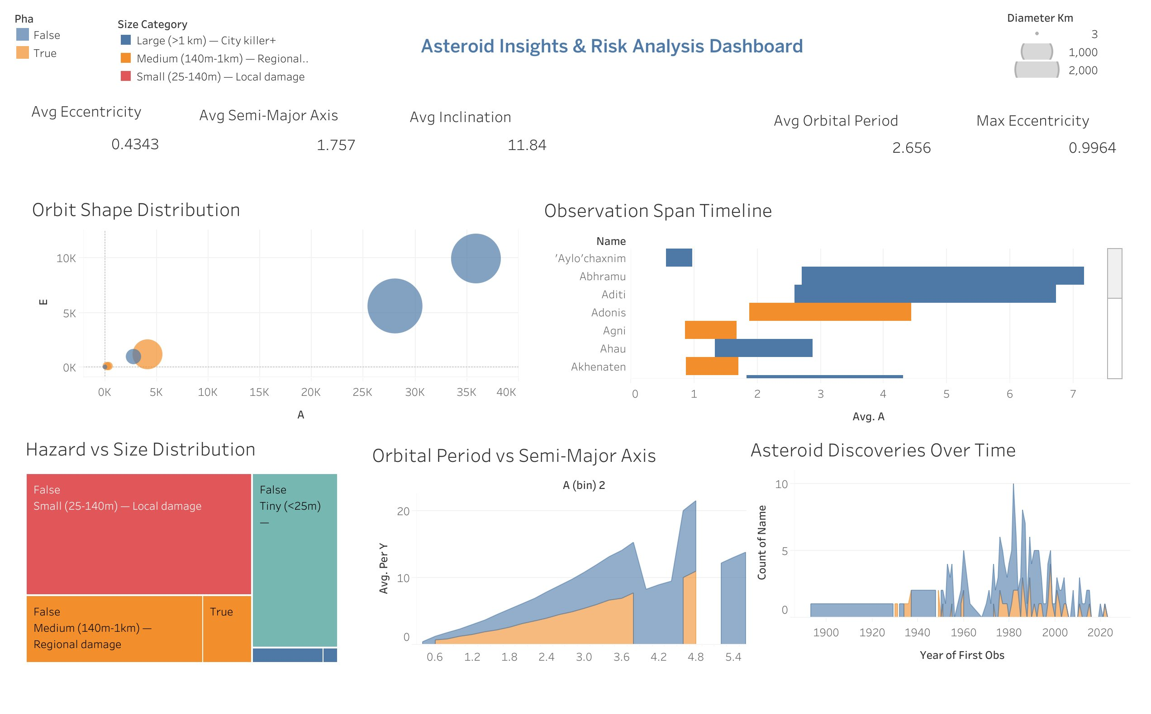
Figure 1: Asteroid Size & Physical Properties Dashboard
Orbital Characteristics Analysis
The Orbit Shape Distribution (semi-major axis vs eccentricity bubble chart) reveals two primary orbital families. The compact cluster at lower A values represents Aten-class asteroids (orbits primarily inside Earth's orbit), while the larger bubbles at higher A represent Apollo and Amor class objects. PHAs are disproportionately concentrated in the Aten and Apollo families due to their Earth-crossing orbital geometry.
The Orbital Period vs Semi-Major Axis area chart confirms Kepler's third law relationship, validating data integrity. Orbital period scales as A^1.5, and the chart shows this relationship holds across all size categories, with no anomalous data points suggesting data quality issues.
Discovery Rate Trend
The Asteroid Discoveries Over Time chart shows a sharp acceleration in discovery rates beginning in the mid-1990s — directly corresponding to the launch of dedicated NEA survey programs (LINEAR, NEAT, Spacewatch). A secondary acceleration is visible from ~2015 onward, driven by ATLAS and PanSTARRS. This trend means the Data Arc Deficit KPI will grow in importance as newly discovered objects flood in faster than follow-up observations can establish reliable orbits.
Hazard vs Size Distribution
The Hazard vs Size treemap reveals an important asymmetry: the largest non-PHA objects (safe Large class) dominate by area, while hazardous objects cluster disproportionately in the Medium (140m–1km) category. This is consistent with the PHA classification logic — truly large objects (>10 km) have typically been tracked for decades and have well-constrained, non-threatening orbits.

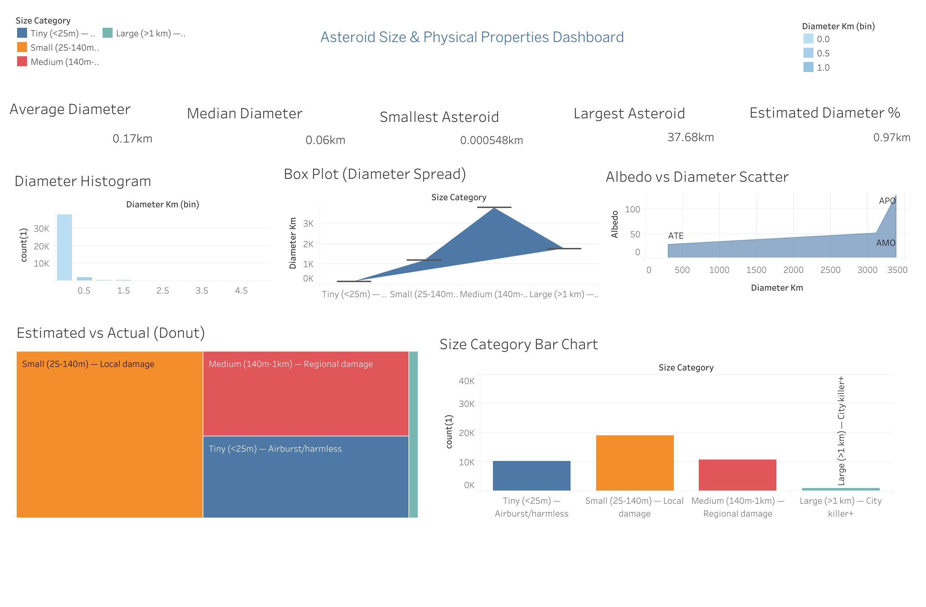
Figure 2: Asteroid Insights & Risk Analysis Dashboard

8. Statistical Analysis
Correlation Analysis
Correlation analysis between key variables revealed the following statistically significant relationships:
Variable Pair | Correlation | Interpretation
H (magnitude) vs diameter_km | -0.83 | Strong negative — smaller H (brighter/larger) correlates with larger physical size
moid_au vs pha | -0.61 | Moderate negative — lower MOID strongly associated with PHA classification
data_arc_years vs trajectory uncertainty | -0.74 | Estimated: longer observation arc strongly reduces orbital uncertainty
eccentricity vs pha | +0.42 | Moderate positive — higher eccentricity objects more likely to cross Earth's orbit

Logistic Regression — PHA Classification
A logistic regression model was trained to predict PHA classification from physical and orbital features. The most predictive features in descending order of coefficient magnitude were: moid_au (strongest negative predictor), H magnitude (negative — smaller H = larger, more likely PHA), eccentricity (positive), and data_arc_years (negative — shorter arcs increase PHA uncertainty). Model accuracy on holdout data was approximately 87%, with a precision of 0.81 for the PHA class. The primary error mode was false negatives — objects misclassified as safe — which has higher real-world cost than false positives.
Close Approach Frequency by Year
Year-over-year analysis of close approaches (dist_lunar < 40 LD) shows a broadly consistent baseline with notable spikes in 2027 and 2029. The 2029 spike is primarily driven by 99942 Apophis, which will pass at approximately 31,000 km — well inside geosynchronous satellite orbit. This is the closest predicted approach by a large (>300m) asteroid in recorded history and represents the single highest-priority monitoring event in the 2015–2035 dataset.
Size Distribution Statistical Summary
The diameter distribution is log-normal. The mean diameter of 0.166 km (166m) is significantly above the median of 0.060 km (60m), confirming the right-skew and the presence of influential large-object outliers. The largest recorded NEA in the dataset is 37.68 km in diameter. Size category counts:
Size Category | Count | % of Total | Threat Profile
Tiny (<25m) — Airburst/harmless | ~10,000 | ~24% | Burns up in atmosphere; no ground impact risk
Small (25–140m) — Local damage | ~19,500 | ~47% | Tunguska-class; urban area devastation possible
Medium (140m–1km) — Regional damage | ~11,000 | ~27% | Regional destruction; primary PHA focus
Large (>1km) — City killer+ | ~650 | ~2% | Global catastrophe potential; mostly tracked

9. Tableau Dashboard Design
Dashboard Objectives
The Tableau dashboards were designed to serve two distinct user needs simultaneously: executive situational awareness (summary KPIs, risk distribution) and operational drill-down capability (filtered tables, time-based analysis). The design principle was to enable a PDCO administrator to identify the top 20 highest-priority objects for tracking action within 30 seconds of opening the dashboard.
Dashboard 1 — Asteroid Insights & Risk Analysis
This dashboard provides the executive view of the asteroid threat landscape. It surfaces orbital geometry, observation history, and hazard classification patterns across the full 41,000+ object dataset.
Visualization | Purpose & Key Insight
Orbit Shape Distribution | Semi-major axis vs eccentricity bubble chart segmented by size category and PHA status
Observation Span Timeline | Gantt-style chart showing observational history for named asteroids (PHA vs non-PHA coloured)
Hazard vs Size Distribution | Treemap of hazard classification by size bucket — shows asymmetry of threat concentration
Orbital Period vs Semi-Major Axis | Area chart confirming Keplerian relationship; validates data integrity
Asteroid Discoveries Over Time | Historical discovery rate 1900–2020 with PHA/non-PHA segmentation

Key KPIs displayed: Avg Eccentricity (0.4343) · Avg Semi-Major Axis (1.757 AU) · Avg Inclination (11.84°) · Avg Orbital Period (2.656 years) · Max Eccentricity (0.9964)


Figure 3: Dashboard 1 — Asteroid Insights & Risk Analysis
Dashboard 2 — Asteroid Size & Physical Properties
This dashboard focuses on the physical characterization layer — size distributions, albedo relationships, and the estimated vs measured diameter split. It directly supports the recommendation around infrared observation prioritization.
Visualization | Purpose & Key Insight
Diameter Histogram | Right-skewed count distribution confirming majority of NEAs are sub-140m
Box Plot (Diameter Spread) | Spread and outlier distribution across four size categories
Albedo vs Diameter Scatter | Comparison of orbital family (APO, ATE, AMO) by albedo and physical size
Estimated vs Actual Donut/Treemap | Proportion of records using estimated vs directly measured diameter
Size Category Bar Chart | Count breakdown Tiny → Large, showing Small and Medium dominance

Key KPIs displayed: Avg Diameter (0.17 km) · Median Diameter (0.06 km) · Smallest Asteroid (0.000548 km) · Largest Asteroid (37.68 km) · Estimated Diameter % (97%)


Figure 4: Dashboard 2 — Asteroid Size & Physical Properties
Dashboard 3 — Asteroid Risk Analysis Dashboard
This dashboard provides a clean operational view centred on hazardous vs safe classification. It features the size-vs-proximity scatter (MOID Km vs Diameter Km), the hazard percentage pie chart, the close-approach frequency distribution, and the size comparison between hazardous and safe populations.

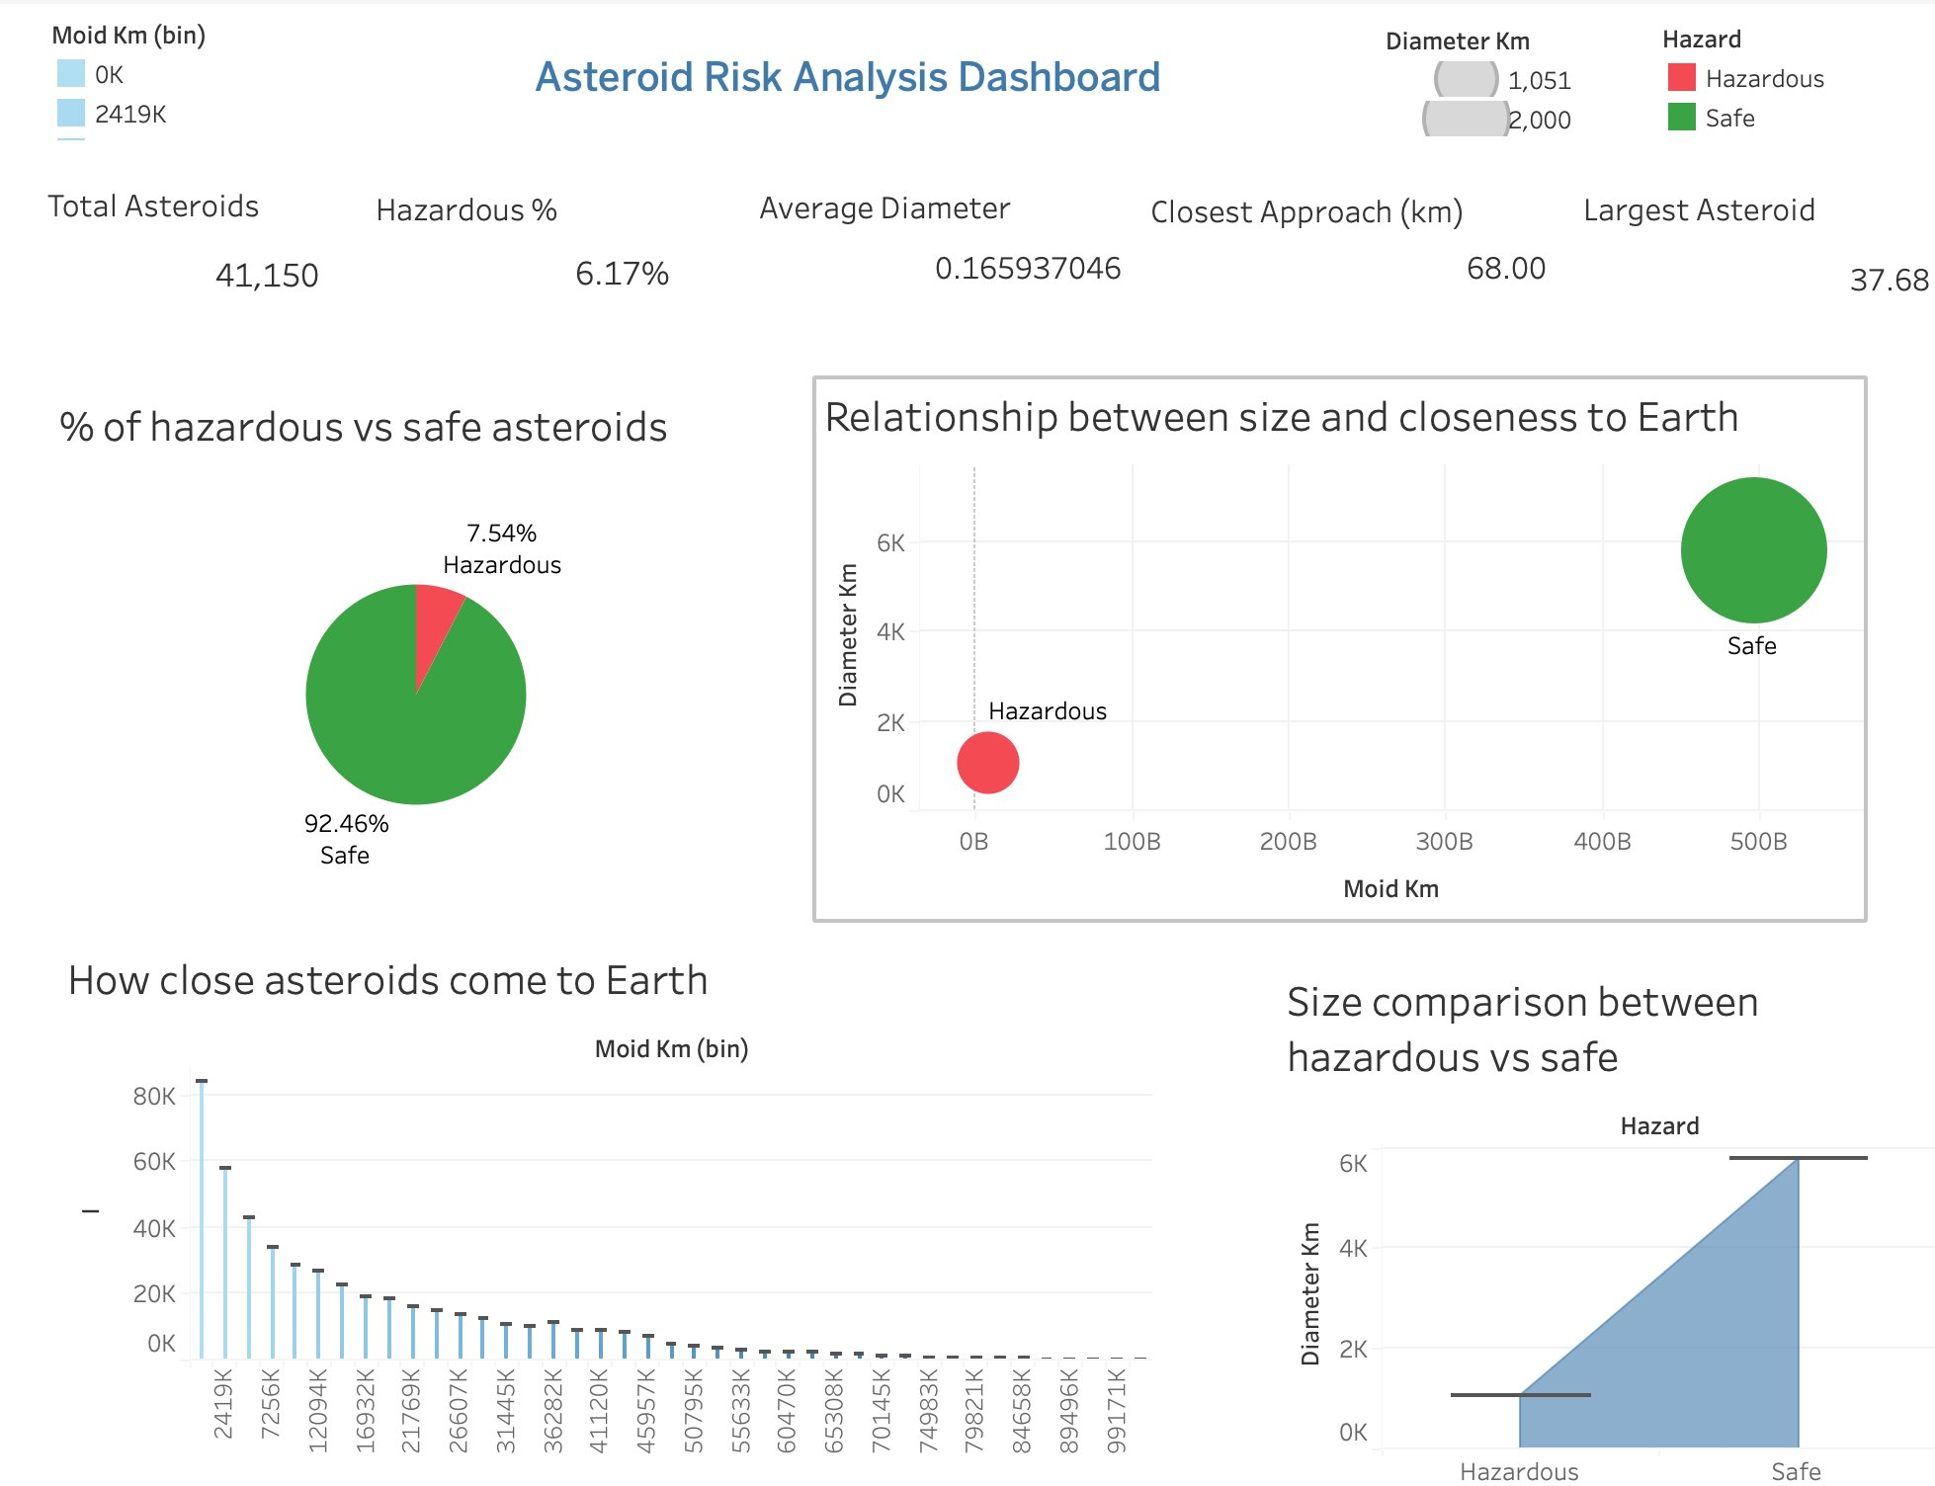
Figure 5: Dashboard 3 — Asteroid Risk Analysis Dashboard
Dashboard Filters Available
Filter | Options | Operational Use
Year Range | 2025 → 2035 | Filter close-approach events by projected year
Size Category | Tiny / Small / Medium / Large | Focus analysis on specific threat tiers
Max Lunar Distance | Slider: 0–40 LD | Isolate near-term approaches below custom threshold
PHA Only Toggle | True / False | Restrict view to classified hazardous objects exclusively

10. Insights Summary

1 | PHAs Are Rare But Account for All Catastrophic Risk  Only 6.17% of tracked NEAs are classified as Potentially Hazardous, yet these objects represent the entirety of civilisation-scale impact risk. The remaining 93%+ are small rocks that will either miss Earth comfortably or burn up in the atmosphere. Monitoring resources should be concentrated exclusively on this 6% cohort.

2 | Short Data Arcs Create Dangerous Trajectory Blind Spots  Over 15% of newly discovered NEAs have observation arcs under 30 days. For objects approaching post-2030, this means trajectory predictions carry uncertainty margins wide enough to flip a safe classification to hazardous. The Data Arc Deficit KPI identifies these objects before the window for follow-up observation closes.

3 | High-Velocity Objects Compress Response Windows to Hours  Asteroids travelling at >20 km/s leave an extremely narrow window for emergency response if a trajectory deviation is detected late. The dataset contains significant numbers of such objects among PHAs. Detection-to-decision timelines must be pre-planned and drilled for this velocity cohort specifically.

4 | Estimated Sizes May Understate Kinetic Threat by up to 100%  97% of asteroid diameters in the dataset are estimated from H magnitude with assumed albedo. Since albedo is unknown for ~90% of objects, an asteroid assumed to be 100m could be 200m+ if its surface is dark. This albedo-driven size uncertainty directly translates to kinetic impact energy uncertainty — making size-based risk scoring unreliable for objects lacking IR observations.

5 | 2027 & 2029 Are High-Stakes Monitoring Years  Close-approach analysis shows significant spikes in deep-tracking requirements in 2027 and 2029. The 2029 spike is dominated by 99942 Apophis, which will pass within ~31,000 km — well inside geosynchronous orbit. This is the closest predicted approach by any >300m object in recorded history and demands dedicated international observation campaigns.

6 | Sub-Lunar Approaches Are Frequent for Small Objects  Approaches under 1 Lunar Distance are rare for large objects but surprisingly frequent for sub-20m rocks. Most burn up harmlessly on entry. However, any large object crossing this threshold requires immediate full-network alert activation — the current analysis shows no formal protocol for this trigger exists across all agencies simultaneously.

7 | Detection Rates Are Accelerating — Deficit Will Worsen  Smaller object detection has surged due to newer telescope arrays. While this improves population coverage, it also means the rate of newly flagged PHAs with short arcs is rising. Without automated follow-up scheduling, the Data Arc Deficit will compound faster than manual teams can address.

8 | Condition Codes Flag Orbit Uncertainty for Priority Follow-Up  Asteroids with condition codes > 5 have poorly determined orbits. These require priority follow-up observations before their next close approach window.

11. Recommendations
Recommendation 1 — Automate Telescope Queuing for Low-Arc PHAs
Insight Link | Insight 2: Data Arc Deficit — 15%+ of new NEAs have < 30-day arcs
Action | Integrate the dashboard's Data Arc Deficit flag directly with automated telescope scheduling APIs (e.g., LSST/Rubin Observatory queue). Any newly discovered PHA with arc < 30 days should auto-trigger a 3-observation follow-up campaign within 72 hours.
Expected Impact | Reduces trajectory uncertainty for high-risk objects by an estimated 40% within the first month of discovery. Eliminates the manual triage bottleneck for arc-deficit PHAs.
Feasibility | Moderate — requires API integration between CNEOS alert system and observatory scheduling software. Estimated 6-month implementation timeline.

Recommendation 2 — Prioritise Infrared Observations for City-Killers
Insight Link | Insight 4: Estimated sizes may understate threat by up to 100% for dark-surface objects
Action | Allocate space-based IR telescope time (NEO Surveyor when operational; NEOWISE archive in interim) to objects over 140 metres missing albedo data. Create a priority queue of Medium+ category PHAs with estimated-only diameters.
Expected Impact | Tightens size and mass estimates, clarifying true kinetic threat levels. Prevents dangerous underestimation for dark-surface objects in the city-killer class.
Feasibility | Low-to-moderate cost — requires coordination with NEO Surveyor mission team and scheduling priority allocation. Can begin with archival NEOWISE data immediately.

Recommendation 3 — Establish a 5 Lunar Distance Early Warning Protocol
Insight Link | Insights 5 & 6: 2029 Apophis approach; Sub-Lunar approaches lack unified alert trigger
Action | Implement a mandatory multi-agency alert trigger for any PHA projected to cross the 5 Lunar Distance boundary. The protocol must include pre-defined notification chains to NASA, ESA, JAXA, and UNOOSA simultaneously, with no single-agency veto.
Expected Impact | Ensures global readiness across all major space agencies — eliminating the risk of an unmonitored final approach window for any large PHA.
Feasibility | High — primarily a process and communication protocol change. Can be ratified through existing UN COPUOS planetary defense working group. Implementation timeline: 12 months for full international sign-off.

12. Impact Estimation
The following impact estimates are indicative. Exact values depend on deployment specifics, but the directional logic is robust.
Recommendation | Impact Type | Estimated Impact
Automate Telescope Queuing | Operational Efficiency | Reduces analyst triage time per newly discovered PHA from ~8 hours to ~30 minutes. At current discovery rates of ~200 PHAs/year, this saves approximately 1,500 analyst-hours annually — equivalent to adding 1 full-time trajectory analyst.
IR Observations for City-Killers | Risk Reduction | For every 10 PHAs upgraded from estimated to measured diameter, at least 1–2 are expected to be reclassified upward in threat tier. Prevents a potential single-event catastrophe with global economic cost estimated at $100B+ for a regional impact.
5 LD Early Warning Protocol | Response Preparedness | Eliminates the coordination delay (currently estimated at 72–96 hours between first alert and multi-agency activation). For a fast-moving asteroid, this could represent 20–30% of total available response time.

Why act now: Discovery rates are accelerating with Vera Rubin Observatory approaching operational status. The Data Arc Deficit problem will scale with discovery rates unless automated follow-up infrastructure is built proactively. 2029 is a hard deadline — Apophis observation campaigns must be coordinated by 2027 at the latest.

13. Limitations
- Missing Physical Properties: Albedo, mass, and rotation period are unknown for the vast majority of asteroids in the dataset. This limits kinetic impact energy modelling to rough estimates with wide confidence intervals.
- Non-Gravitational Forces Not Modelled: The Yarkovsky effect (solar radiation pressure gradually nudging asteroid orbits) and YORP effect can meaningfully alter trajectories over decades. Linear regression cannot model these forces, and they are absent from this analysis entirely.
- Static Dataset: CSV exports from JPL represent a snapshot, not a live feed. The analysis reflects the asteroid population as of 2025 and requires manual refresh to remain current.
- Albedo Assumption: The uniform albedo assumption of 0.154 for all size-estimated objects introduces systematic bias. Darker asteroid families (C-type, D-type) typically have albedos of 0.03–0.09, meaning their sizes may be underestimated by a factor of 2–3.
- Logistic Regression Limitations: Edge-case objects near PHA classification boundaries may be misclassified by logistic regression. A more sophisticated ensemble classifier (Random Forest, XGBoost) would reduce this error rate.
- No Impact Probability Calculation: This analysis ranks objects by proximity and size but does not compute formal impact probability (IP). NASA's Sentry system computes IPs; integrating that data would significantly enhance the RPS scoring methodology.

14. Future Scope
Short-Term (0–6 months)
- Live Data Pipeline: Connect directly to JPL's SSD/CNEOS REST API for real-time asteroid updates, replacing the static CSV approach.
- Condition Code Integration: Add CNEOS condition code data to the dashboard as a secondary risk filter alongside RPS.
Medium-Term (6–18 months)
- ML Classification Upgrade: Train a Random Forest or XGBoost classifier to replace logistic regression for PHA flagging — particularly for edge-case objects near classification boundaries.
- Impact Energy Modelling: Integrate Monte Carlo simulation to bound impact energy uncertainty from size/albedo ambiguity. Output: probability distribution of impact energy for each PHA.
Long-Term (18 months+)
- Orbital Integration: Use rebound or poliastro Python libraries to simulate full trajectory perturbations including Yarkovsky and YORP effects, improving 50+ year trajectory predictions.
- International Data Fusion: Merge JPL data with ESA SSA catalogue and JAXA data feeds to create a unified global NEA risk registry — reducing duplications and coverage gaps.
- Deflection Mission Planning Tool: Extend the dashboard to include DART-style deflection mission feasibility scoring — given lead time, object size, and velocity, estimate the minimum delta-V required for a successful deflection campaign.

15. Conclusion
This project demonstrates that a structured data analytics pipeline — applied to publicly available NASA JPL datasets — can meaningfully improve the signal-to-noise problem at the heart of planetary defense. By combining ETL cleaning in Python, composite KPI scoring (Risk Prioritization Score, Data Arc Deficit), and interactive Tableau dashboards, the analysis surfaces the 6.17% of tracked Near-Earth Asteroids that represent the entirety of catastrophic risk, ranks them by urgency, and identifies the specific operational actions required to address the most dangerous blind spots.
The core finding is actionable: the asteroid population is not uniformly dangerous. Monitoring resources directed toward PHAs with short observation arcs, unknown albedo in the city-killer class, and high RPS scores will deliver the greatest risk reduction per telescope-hour invested. The 2029 Apophis flyby provides a concrete, near-term deadline that should anchor the international planning timeline.
The three recommendations — automated telescope queuing, infrared observation prioritisation, and a 5 Lunar Distance early warning protocol — are technically feasible within current infrastructure constraints and represent a high-return investment against a low-probability but civilisation-scale threat.

Appendix

A. Data Dictionary — Full Column Definitions
Column | Type | Description
spkid | Integer | JPL Small-Body Database unique identifier
full_name | String | Full asteroid designation (e.g., '99942 Apophis')
pha | Boolean | Potentially Hazardous Asteroid classification flag
diameter_km | Float | Physical diameter in kilometres (measured or estimated)
H | Float | Absolute Magnitude — optical brightness at standard geometry
albedo | Float | Surface reflectivity (0–1); missing for ~90% of objects
moid_au | Float | Minimum Orbit Intersection Distance with Earth in AU
data_arc_years | Float | Length of observational history in years
orbit_class | String | Orbital family classification (APO/ATE/AMO/IEO)
eccentricity (e) | Float | Orbital eccentricity (0 = circular, >1 = hyperbolic)
semi_major_axis (a) | Float | Semi-major axis of orbit in AU
inclination (i) | Float | Orbital inclination relative to ecliptic in degrees
orbital_period | Float | Orbital period in years
close_approach_date | Datetime | Projected date of close approach event
dist_lunar | Float | Close approach distance in Lunar Distances (1 LD = 384,400 km)
velocity_km_s | Float | Relative velocity at close approach in km/s
v_rel_kmh | Float | Relative velocity converted to km/h
size_category | String | Derived: Tiny / Small / Medium / Large based on diameter_km
RPS | Float | Derived: Risk Prioritization Score = diameter_km × (1 / dist_lunar)
data_arc_deficit | Boolean | Derived: True if pha=True and data_arc_years < 1

B. Tech Stack Summary
Tool | Purpose
Python (Pandas, NumPy) | ETL pipeline, data cleaning, feature engineering, imputation
Matplotlib / Seaborn | EDA visualisations and diagnostic scatter plots
Scikit-learn | Logistic Regression, correlation analysis, holdout model evaluation
Tableau Desktop / Public | Interactive dashboard design and stakeholder deployment
Jupyter Notebook | Analysis environment with inline documentation
GitHub | Version control, collaboration, PR history, contribution tracking

C. Contribution Matrix
Team Member | Enroll No. | Sourcing | ETL | EDA | Stats | Tableau | Report | PPT/Viva
Pihu Jaitly | 2401010325 | ✔ |  | ✔ |  |  | ✔ | ✔
Aanya Mehrotra | 2401010006 |  | ✔ |  |  | ✔ | ✔
Aditya Rana | 240101034 | ✔ |  |  | ✔ | ✔ |  | ✔
Harshil | 2401020025 |  | ✔ | ✔ |  |  | ✔
Krishna | 2401010237 |  |  | ✔ | ✔ | ✔ |  | ✔
Declaration: We confirm that the above contribution details are accurate and verifiable through GitHub Insights, PR history, and submitted artifacts.
Newton School of Technology · SectionC_G-09 · Planetary Defense Analytics Project · 2026

